Step 1 : Created a directory /user/acadgild/hadoop.

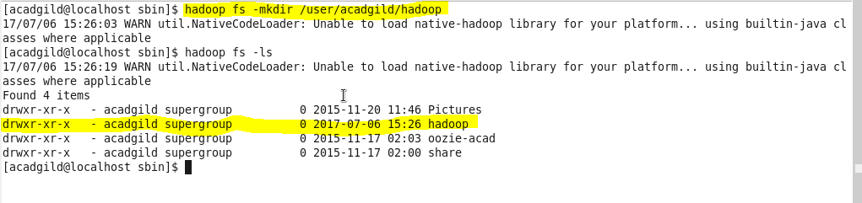

Step 2: created a file word-count

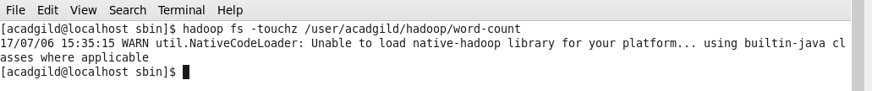

Append to file

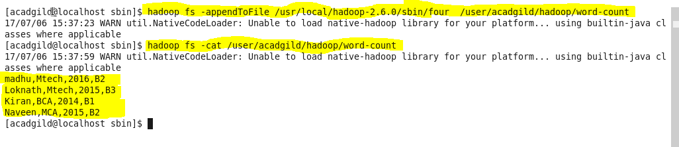

Step :3 created max-temp.txt in local with data

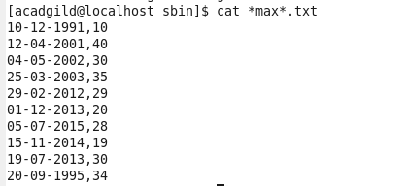

Moved file to HDFS at /user/acadgild/hadoop

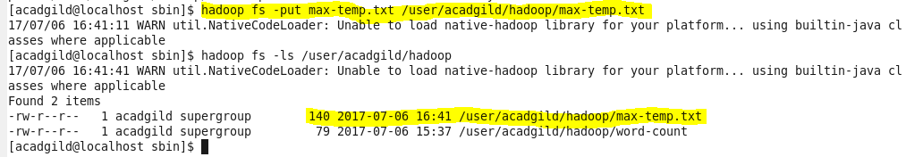

Step 4: Changed the permission of the file /user/acadgild/hadoop/max-temp.txt, such that only the owner and the group members have full control over the file.

